

PRN212 - Project 04

Building a Employee Management System

With Window Presentation Foundation

Bùi Tiến Quát

Đoàn Anh Đức  
Nguyễn Nhật Minh

Nguyễn Mạnh Dũng

— Hanoi, July 19, 2024 —

# Introduction

The Employee Management System (EMS) is an essential tool designed to streamline and automate the processes involved in managing an organisation's human resources. This system provides a comprehensive solution for handling employee data, job roles, departments, and locations. Built using Windows Presentation Foundation (WPF) and following a three-layer architecture, the EMS leverages modern technologies such as Entity Framework Core for database operations and LINQ for data querying and sorting.

# Document description

This document describes the OO version 1.0 solution for the Employee Management System. It is divided into the following sections:

In part 2, an overview of the system requirements will be provided, including a list of system users, use cases, use case diagrams, and activity diagrams depicting the most important use case situations.

Part 3 will detail the E-R diagram and all the tables of the store system.

In section 4, all classes are organised by class and their behaviour (sequence diagram) for the most important use cases is presented.

In section 5 most of the screen prototypes will be presented.

# EMS Overview

## 3.1 List of system users

1. Admin: The person who manages all the employees
2. User: The people can view their own information

## 3.2 List of use cases

1. Log in
2. Log out
3. View profile of employee
4. Add employee
5. Delete employee
6. Update profile
7. Export Txt and JSON

## 3.3 Use case diagram

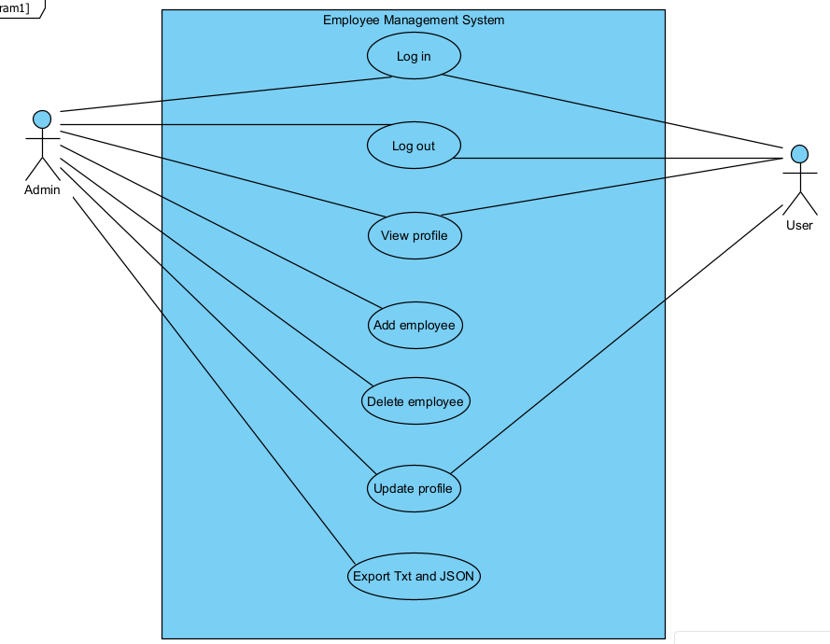

3.4 Activity Diagrams

3.4.1 Use case “Log in”

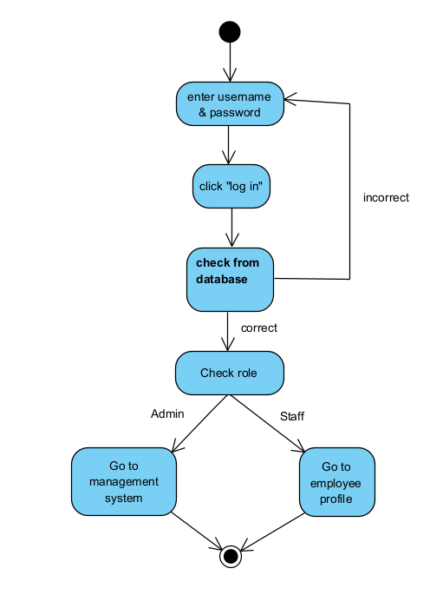

3.4.2 Use case “View profile”

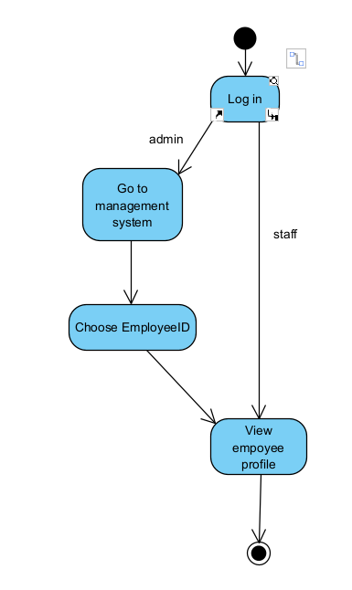

3.4.3 Use case “Log out”

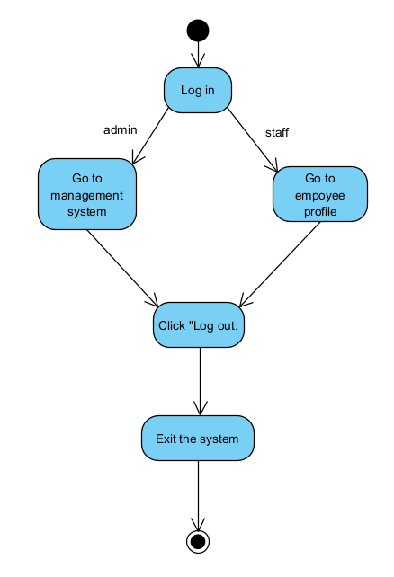

3.4.4 Use case “Add employee”

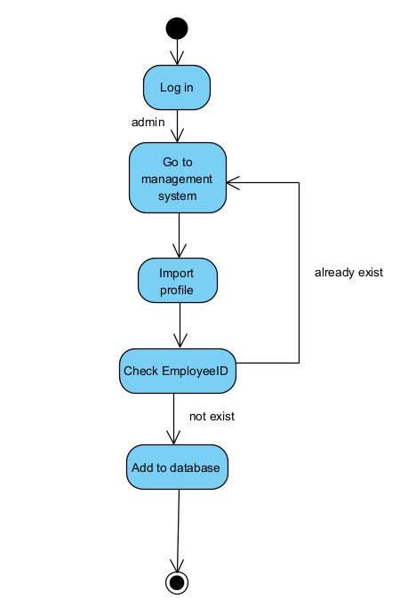

3.4.5 Use case “Delete employee”

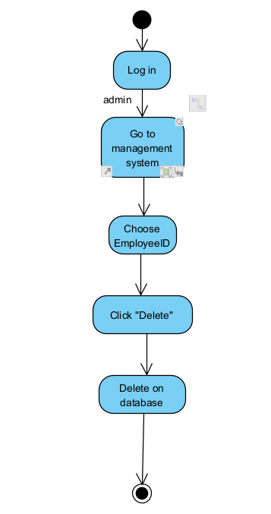

3.4.6 Use case “Update profile”

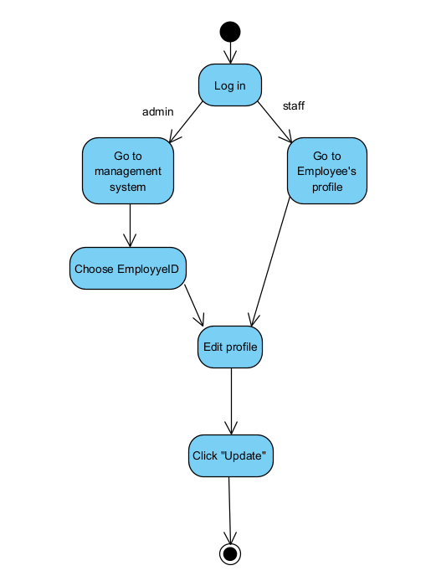

3.4.7 Use case “Export Txt & JSON”

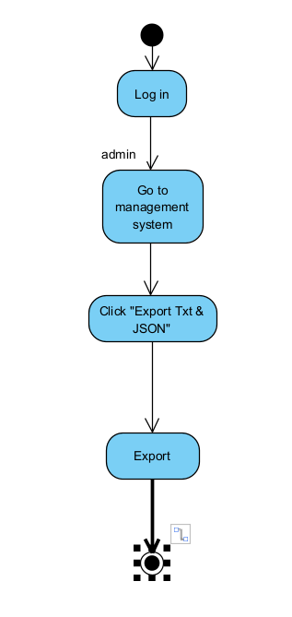

# Data model

## 4.1 Diagram

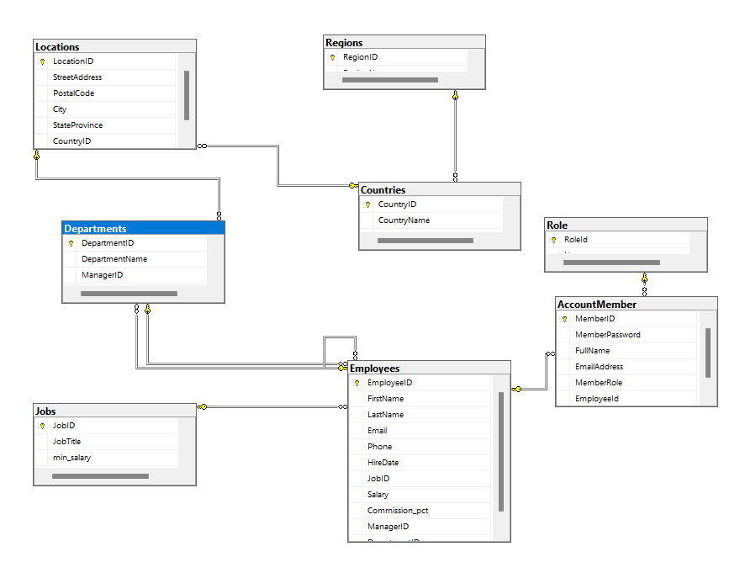

## 4.2 Table details

### AccountMember:

| **Field name** | **Type** | **Size** | **Note** |
| --- | --- | --- | --- |
| MemberID | int |  | NOT NULL |
| MemberPassword | nvarchar | 80 | NOT NULL |
| FullName | nvarchar | 80 |  |
| EmailAddress | nvarchar | 100 |  |
| MemberRole | int |  | NOT NULL |

### Countries:

| **Field name** | **Type** | **Size** | **Note** |
| --- | --- | --- | --- |
| CountryID | varchar | 10 | NOT NULL |
| CountryName | varchar | 50 |  |
| RegionID | int |  |  |

### Departments:

| **Field name** | **Type** | **Size** | **Note** |
| --- | --- | --- | --- |
| DepartmentID | int |  | NOT NULL |
| DepartmentName | varchar | 50 |  |
| ManagerID | int |  |  |
| LocationID | varchar | 5 |  |

### Employees:

| **Field name** | **Type** | **Size** | **Note** |
| --- | --- | --- | --- |
| EmployeeID | int |  | NOT NULL |
| FirstName | varchar | 30 |  |
| LastName | varchar | 30 |  |
| Email | varchar | 50 |  |
| Phone | varchar | 20 |  |
| HireDate | date |  |  |
| JobID | varchar | 20 |  |
| Salary | float |  |  |
| Commission_pct | float |  |  |
| ManagerID | int |  |  |
| DepartmentID | int |  |  |

### Jobs:

| **Field name** | **Type** | **Size** | **Note** |
| --- | --- | --- | --- |
| JobID | varchar | 20 | NOT NULL |
| JobTitle | varchar | 100 |  |
| min_salary | int |  |  |
| max_salary | int |  |  |

### Locations:

| **Field name** | **Type** | **Size** | **Note** |
| --- | --- | --- | --- |
| LocationID | varchar | 5 | NOT NULL |
| StreetAddress | varchar | 100 |  |
| PostalCode | varchar | 20 |  |
| City | varchar | 30 |  |
| StateProvince | varchar | 30 |  |
| CountryID | varchar | 10 |  |

### Regions:

| **Field name** | **Type** | **Size** | **Note** |
| --- | --- | --- | --- |
| RegionID | int |  | NOT NULL |
| RegionName | varchar | 30 |  |

### Role:

| **Field name** | **Type** | **Size** | **Note** |
| --- | --- | --- | --- |
| RoleId | int |  | NOT NULL |
| Name | varchar | 20 | NOT NULL |

# Class Diagram

## List of classes in the Layers

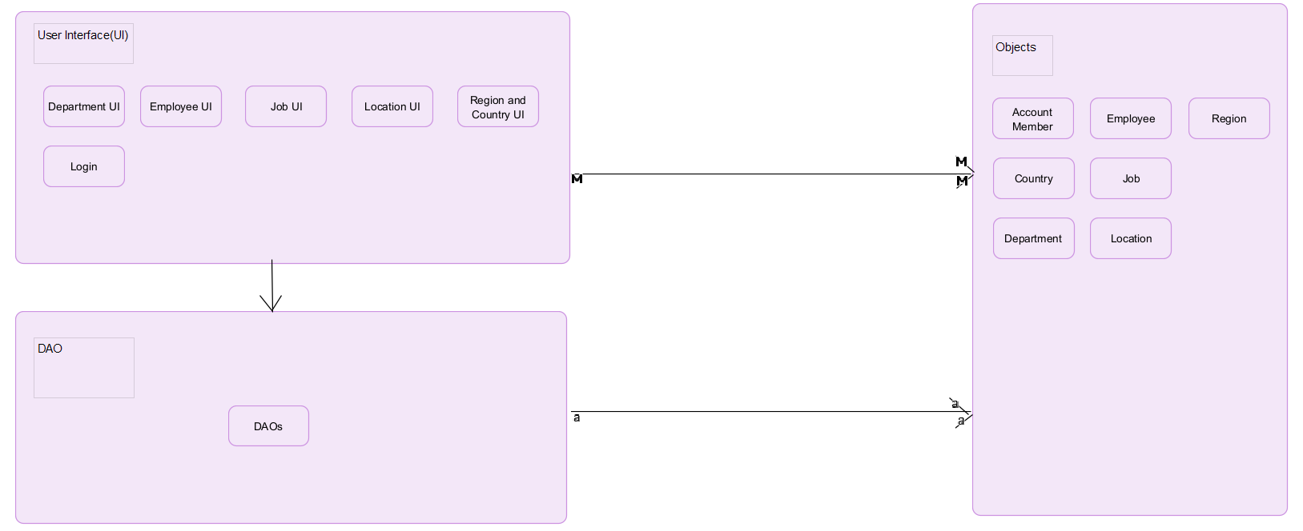

## Sequence diagram for use case “View detail”

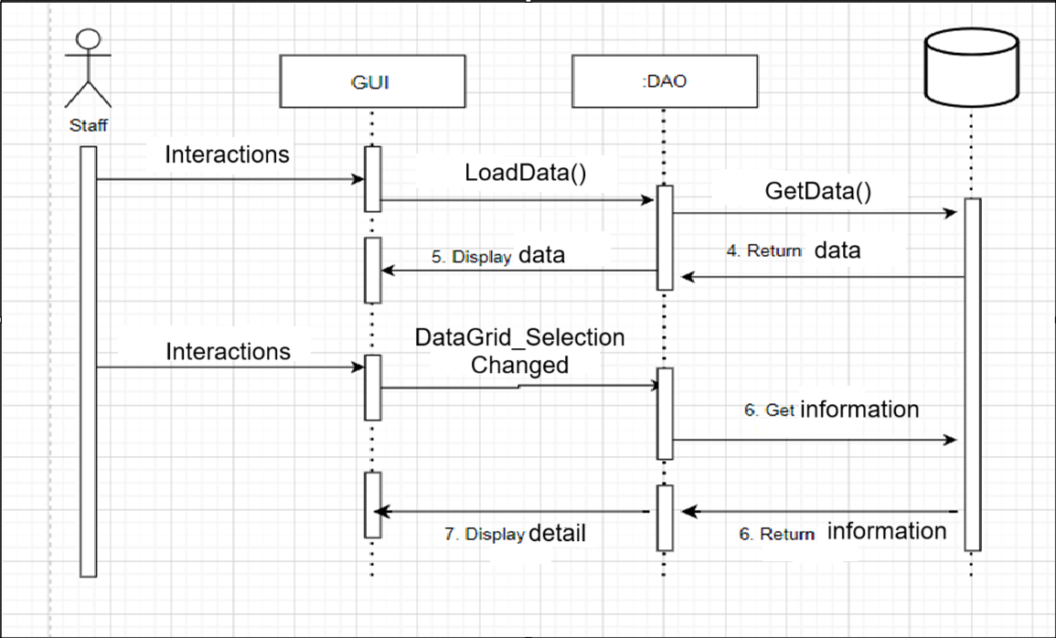

# Screen Detail

6.1. Screen “Login”

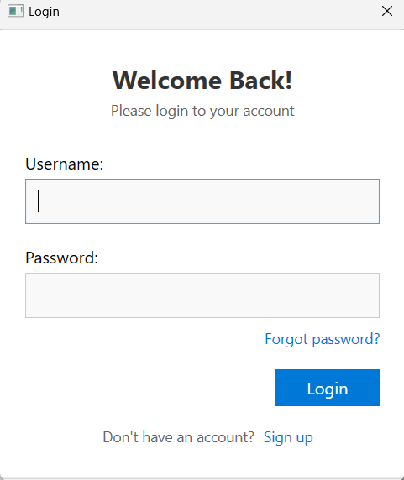

**Login screen description:**

Step 1: Enter email and password

Step 2: Click the Login button

Step 3: The system will check the login Role

+ If role = 1 => transfer to the admin page (Employee Managenment)

+ Role = 2 => Transfer to Staff (Employee Profile)

6.2. Screen “Register”

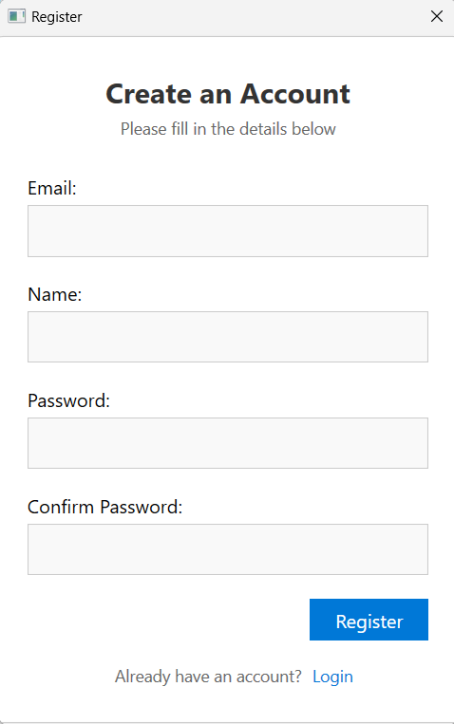

**Description of Register screen**

Step 1: Enter Email, Name, Password, Confirm Password

Step 2: Click the Register button

Step 3: The system will check the registered account that has met the small lice

+ Check whether the email is in the correct format

+ Check the password is over 8 characters, including 1 special character and flower printing

Step 4: If you meet the criteria, users will be transferred to the login form. If not responded, it will understand the invalid notice and re -register from the beginning

6.3. Screen “Employee Management”

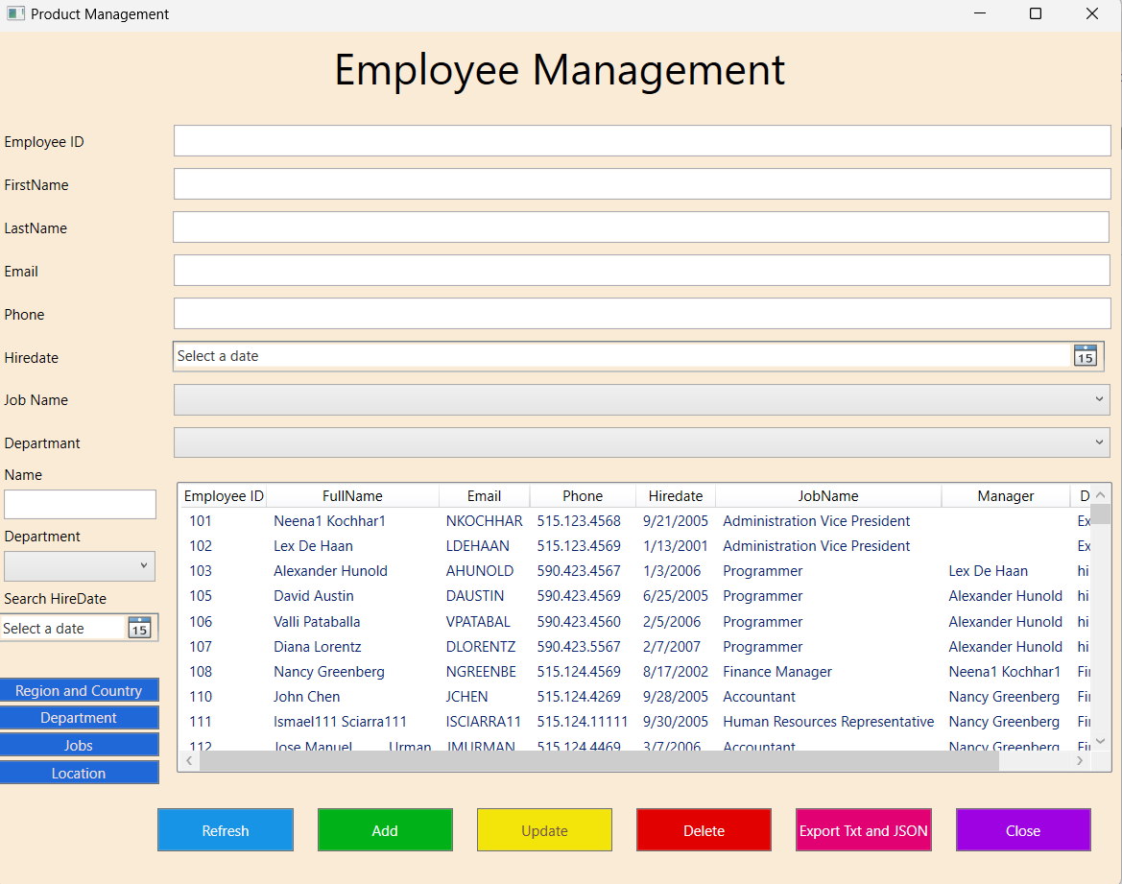

6.4. Screen “Country”

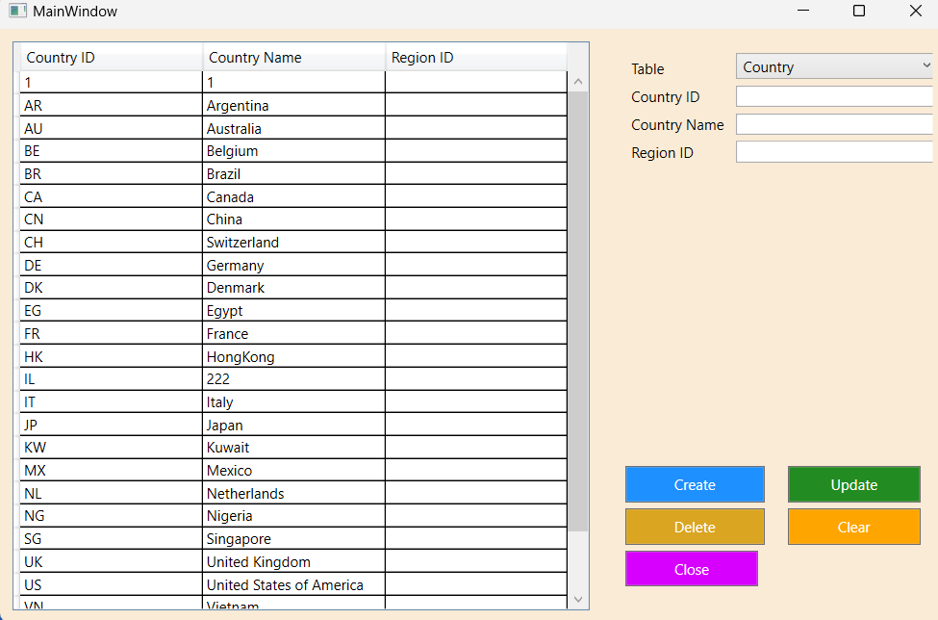

6.5. Screen “Region”

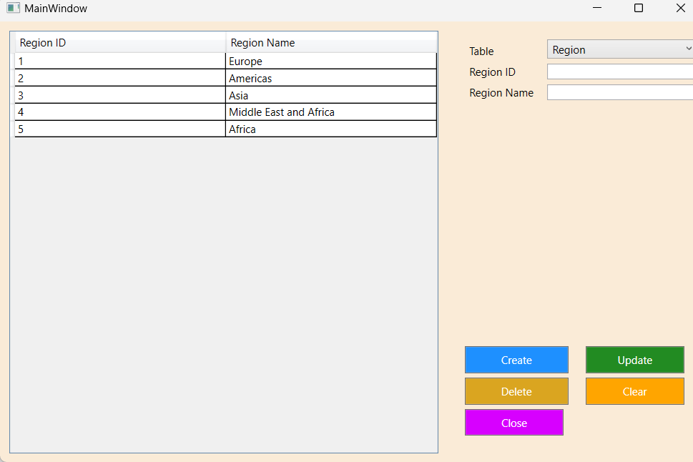

6.6. Screen “Department”

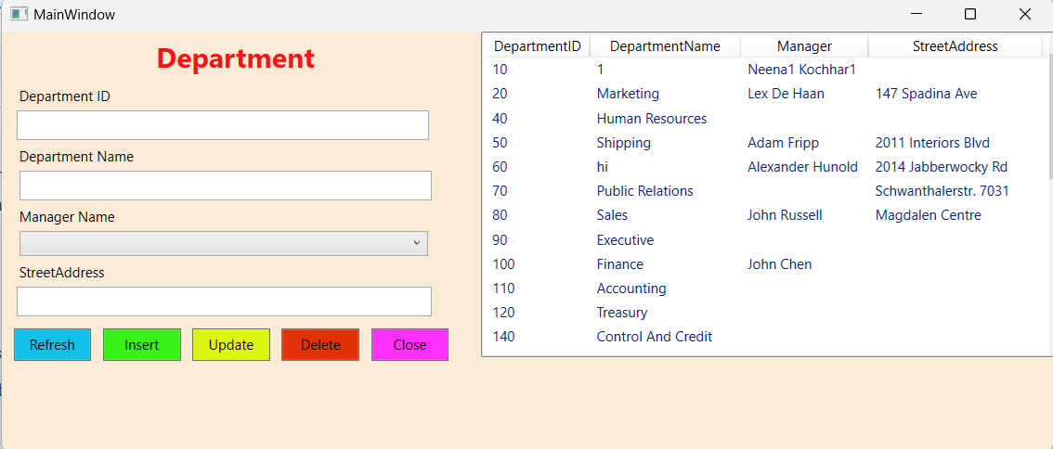

6.7. Screen “Job”

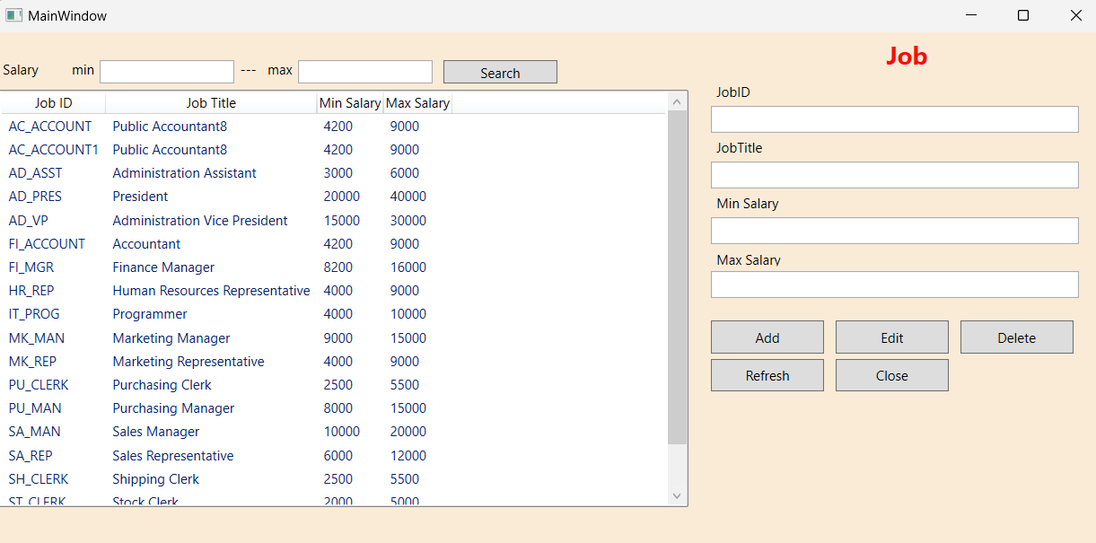

6.8. Screen Location

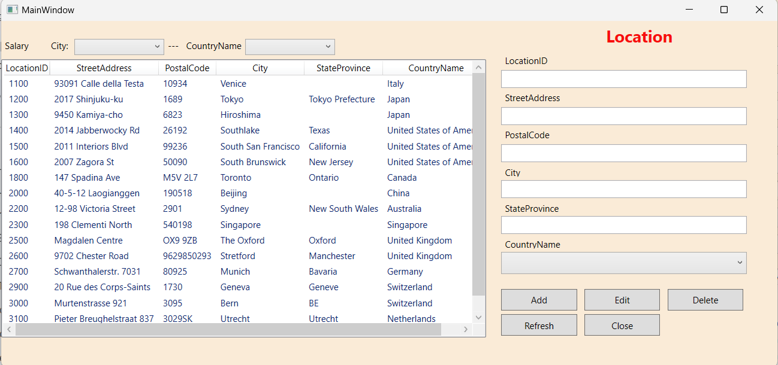

6.9. Screen user

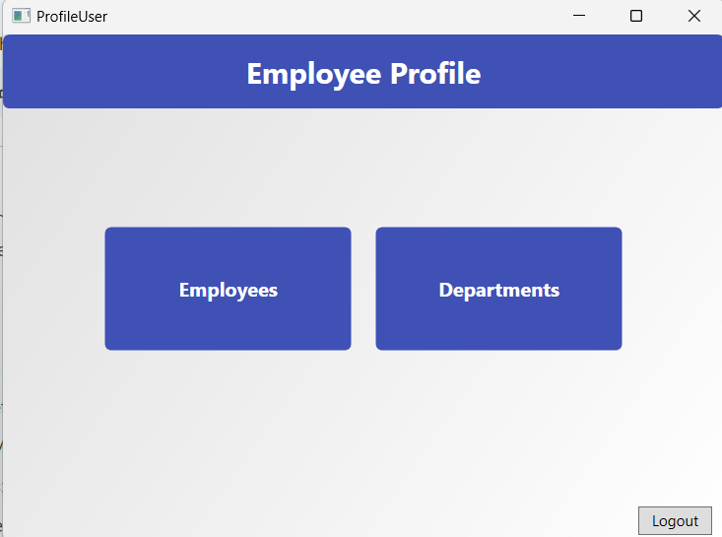

6.10. Screen user view employees

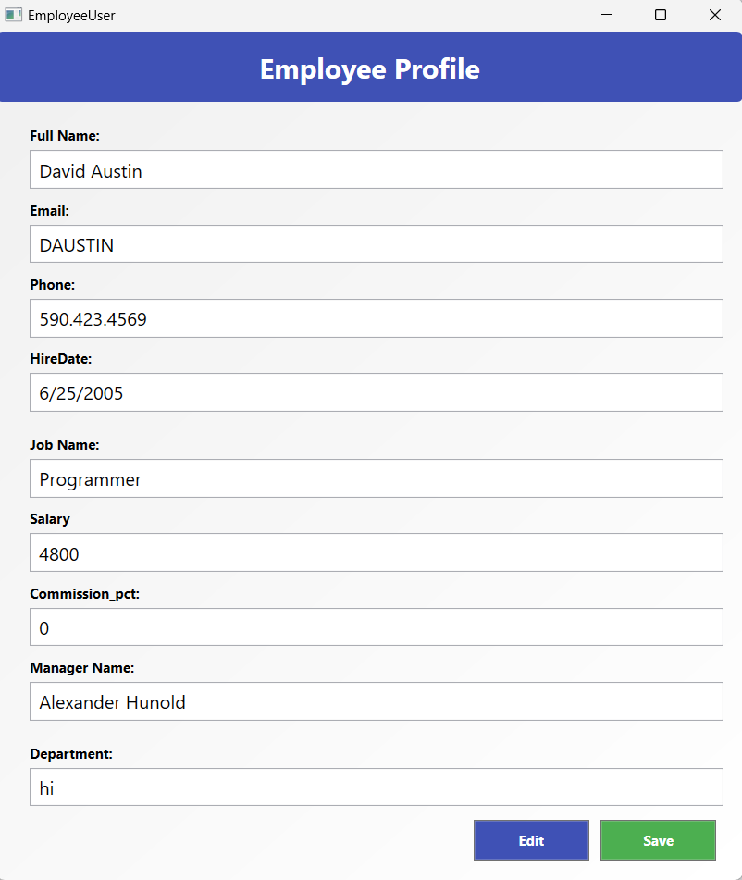

6.11. Screen user view department

